

Project Report
Submitted by:
Muhammad Kamran Haider 23014119-085
Luqman Ali 23014119-054
Submitted to:
Mr. Atif Shehzad
Department:
BS Computer Science
Subject:
Advanced Web Development(AWD)
Semester:
Fall 2025
Section:
B (Evening)
Course Code:
CS-408

TEACHER APPOINTMENT BOOKING SYSTEM
Project Report

1. PROJECT OVERVIEW
Title: Teacher Appointment Booking System
Technology Stack: MERN (MongoDB, Express.js, React.js, Node.js)
Objective: A web-based platform for students to book appointments with teachers efficiently.

2. PROBLEM STATEMENT
In educational institutions, scheduling meetings between students and teachers faces several challenges:
Current Problems:
- Manual Scheduling: Teachers maintain physical appointment books or use emails
- Time Conflicts: Multiple students may book the same slot accidentally
- No Real-time Availability: Students cannot see teacher availability instantly
- Access Issues: No centralized system for appointment management
- Security Concerns: No proper authentication for different user roles
Solution Provided:
A responsive web application where:
- Students can view real-time teacher availability
- Teachers can manage their schedules
- System prevents double booking
- Secure authentication for students and teachers
- All data stored in cloud database

3. DATABASE DESIGN
3.1 Schema Diagram
text
┌─────────────────┐ ┌─────────────────┐ ┌─────────────────┐
│ USERS │ │ TEACHERS │ │ APPOINTMENTS │
├─────────────────┤ ├─────────────────┤ ├─────────────────┤
│ _id │ │ _id │ │ _id │
│ username │◄────►│ name │◄────►│ studentName │
│ password (hash) │ │ subject │ │ teacherName │
│ role │ │ availableTime │ │ time │
│ teacherName │ └─────────────────┘ │ createdAt │
│ createdAt │ └─────────────────┘
└─────────────────┘
3.2 Collections Details
1. Users Collection
javascript
{
username: "student1", // Unique identifier
password: "hashed_pwd", // BCrypt encrypted
role: "student", // "student" or "teacher"
teacherName: "", // Only for teacher accounts
createdAt: Date
}
2. Teachers Collection
javascript
{
name: "Sir Ali",
subject: "Web Development",
availableTime: "10:00,11:00,12:00,14:00"
}
3. Appointments Collection
javascript
{
studentName: "John Doe",
teacherName: "Sir Ali",
time: "10:00",
createdAt: "2024-01-20T09:30:00Z"
}
3.3 Relationships
- One Teacher can have many Appointments
- One Student can have many Appointments
- User (teacher role) links to Teacher profile

4. SYSTEM FEATURES
4.1 Authentication System
- Student Signup/Login: Create account or login with credentials
- Teacher Login: Secure login with username/password
- JWT Tokens: Secure session management
- Role-based Access: Different dashboards for students/teachers
4.2 Student Features
- View all available teachers
- See real-time available time slots
- Book appointments with selected teachers
- View booking history
- Secure profile management
4.3 Teacher Features
- View all booked appointments
- Manage time availability
- Cancel appointments if needed
- See student details for appointments
4.4 Admin Features
- Initialize database with sample data
- View all system appointments
- Monitor user activities
- System configuration

5. TECHNICAL IMPLEMENTATION
5.1 Frontend (React.js)
- Components: Modular React components
- State Management: useState, useEffect hooks
- Routing: React Router for navigation
- Styling: CSS with responsive design
- API Calls: Fetch API for backend communication
Key Components:
- App.jsx - Main application with routing
- StudentAuth.jsx - Student authentication
- TeacherLogin.jsx - Teacher authentication
- Dashboard components for both roles
5.2 Backend (Node.js + Express.js)
- RESTful API: Clean API endpoints
- Authentication: JWT middleware
- Database: MongoDB with Mongoose ODM
- Security: Input validation, password hashing
API Endpoints:
text
GET /api/teachers - List all teachers
GET /api/appointments - Get all appointments
POST /api/appointments - Book appointment
DELETE /api/appointments/:id - Cancel appointment
POST /api/student/signup - Student registration
POST /api/login - User login
GET /api/setup - Initialize database
5.3 Database (MongoDB)
- Collections: Users, Teachers, Appointments
- Indexes: Optimized for frequent queries
- Relations: Referential integrity maintained
- Data Types: Proper validation in schemas

6. SCREENSHOTS

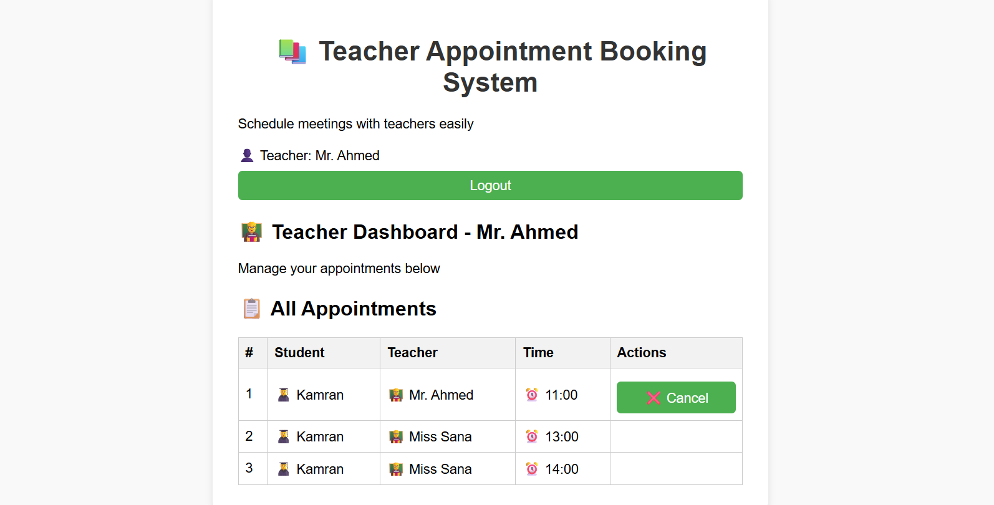
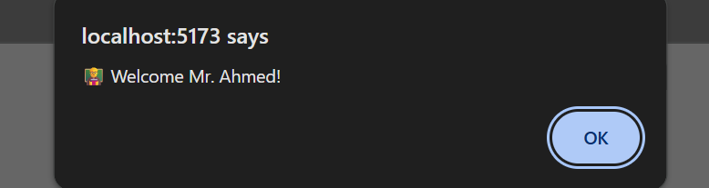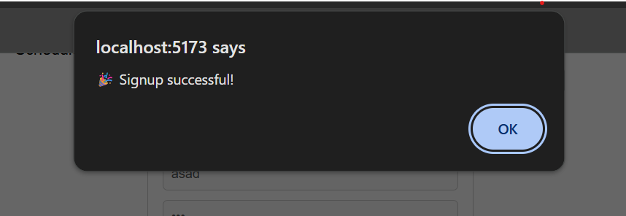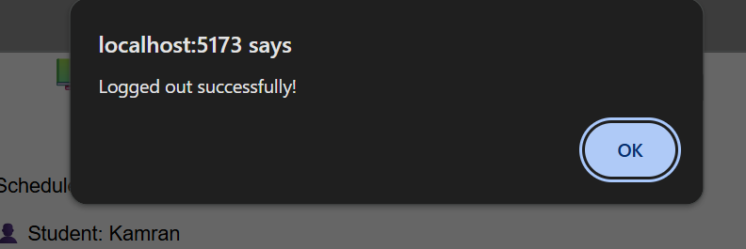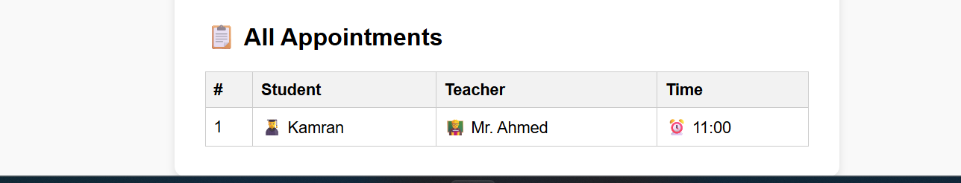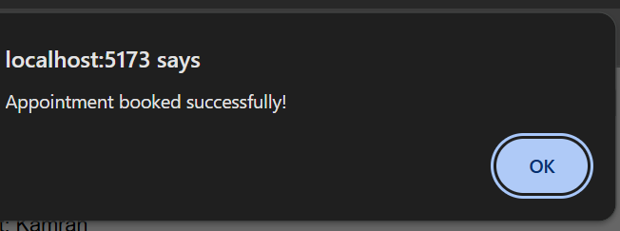
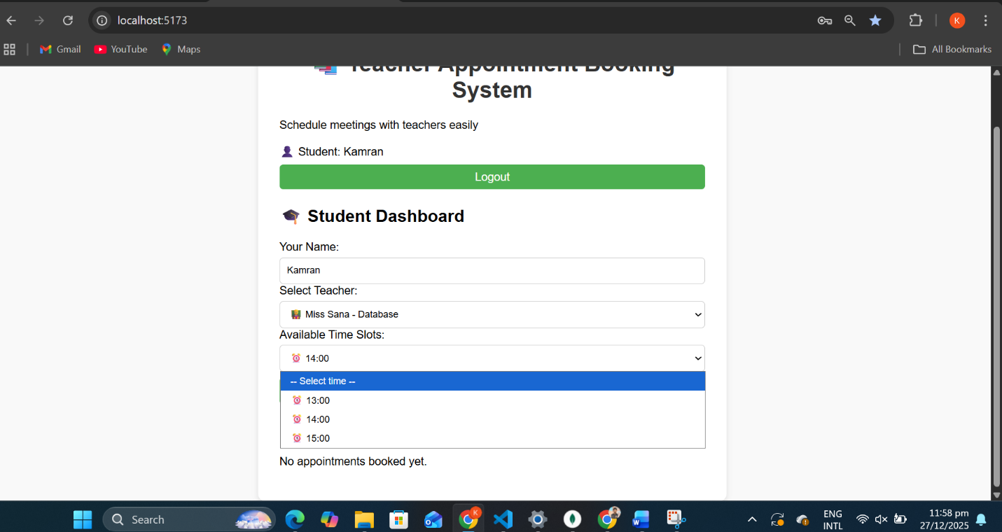
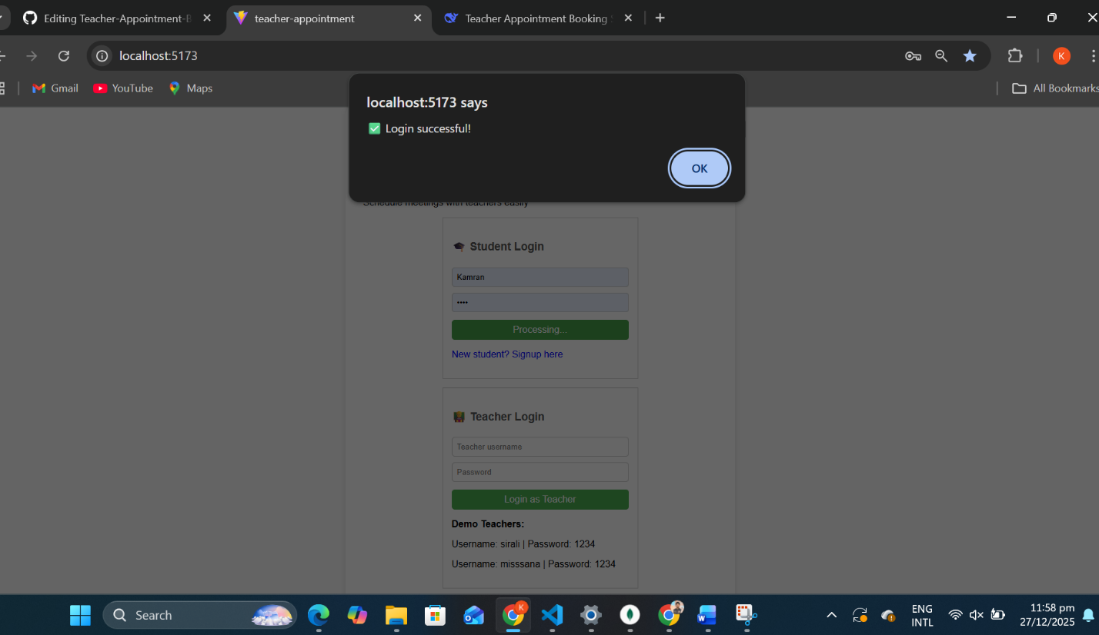
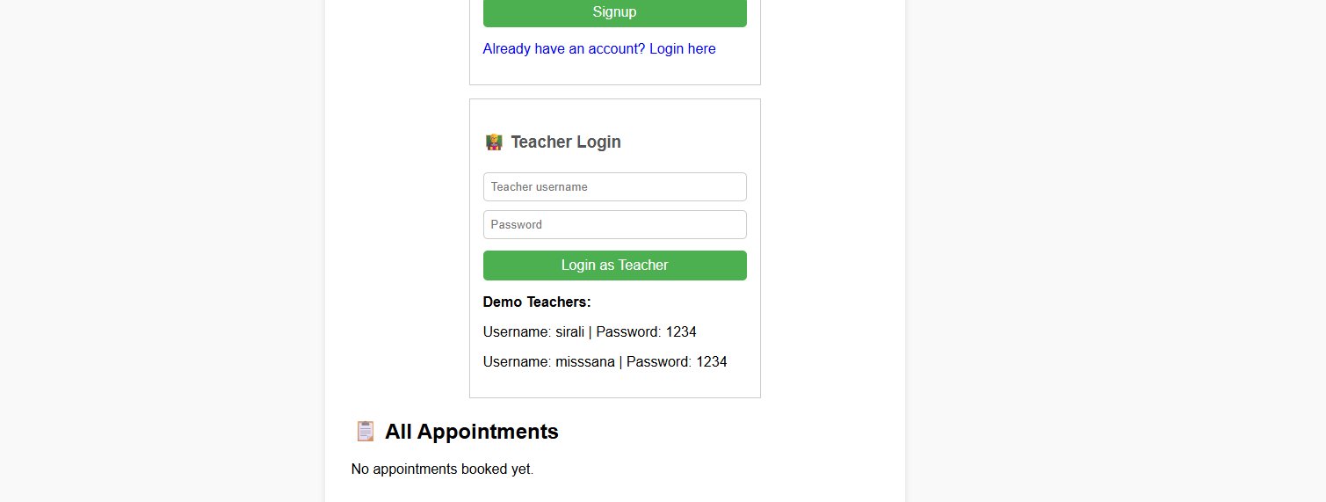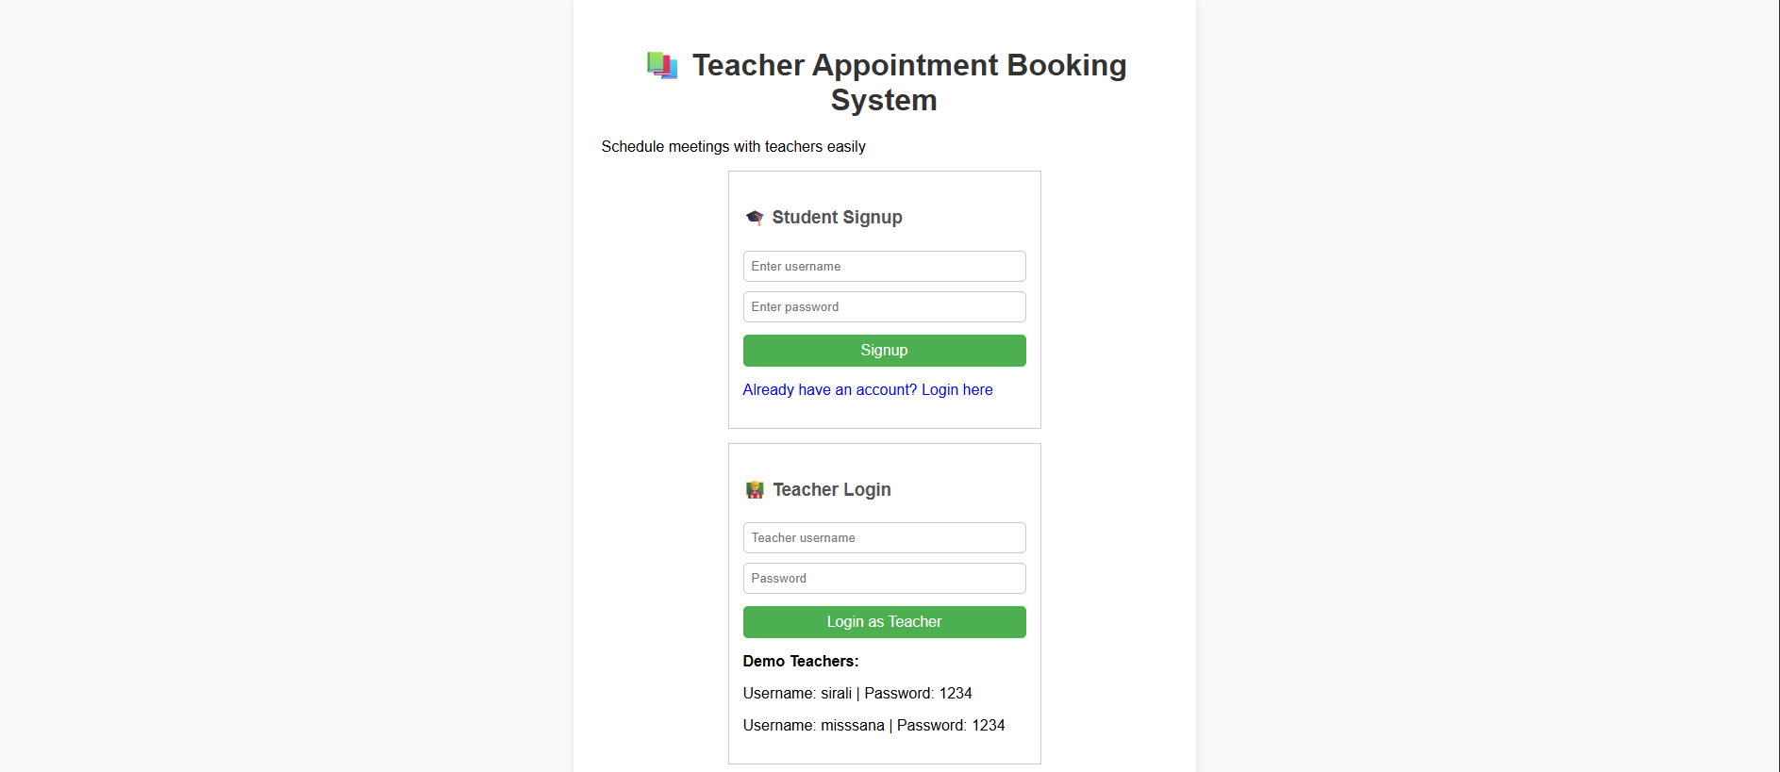

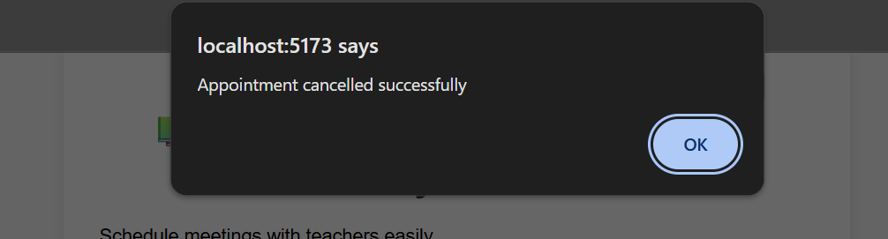

6.1 Home Page
- Clean interface with navigation
- Hero section explaining the system
- Quick access buttons for login/signup
6.2 Student Dashboard
- Welcome message with student name
- Teacher selection dropdown
- Available time slots display
- Appointment booking form
6.3 Teacher Dashboard
- Teacher information display
- Appointment list with student details
- Cancel appointment buttons
- Statistics card
6.4 Appointments Page
- Table showing all appointments
- Student and teacher names
- Time slots
- Booking dates
6.5 Authentication Pages
- Student signup/login forms
- Teacher login form
- Error/success messages
- Demo credentials display
6.6 API Documentation
- List of all available endpoints
- Request/response formats
- Authentication requirements

7. SECURITY FEATURES
7.1 Authentication Security
- Password hashing using BCrypt
- JWT tokens for session management
- Token expiration after 24 hours
- Secure HTTP headers
7.2 Data Security
- Input validation on all forms
- MongoDB injection prevention
- XSS protection
- Secure API endpoints
7.3 Authorization
- Role-based access control
- Teachers can only cancel their appointments
- Students can only book appointments
- Proper error messages for unauthorized access

8. INSTALLATION GUIDE
8.1 Prerequisites
- Node.js (v14 or higher)
- MongoDB (local installation or Atlas)
- Git (for version control)
8.2 Setup Steps
Backend Setup:
bash
cd backend
npm install
npm start
Frontend Setup:
bash
cd frontend
npm install
npm run build
Database Initialization:
- Start MongoDB: mongod
- Visit: http://localhost:5000/api/setup
- Database will be populated with sample data
8.3 Running the Application
- Start backend server: node server.js
- Open browser: http://localhost:5000
- Use demo credentials for testing
8.4 Demo Credentials
text
Teachers:
- Username: sirali, Password: 1234
- Username: misssana, Password: 1234

Student:
- Username: student1, Password: student123

9. CHALLENGES AND SOLUTIONS
9.1 Challenge: Real-time Slot Availability
Problem: Preventing students from booking already booked slots
Solution: Server-side validation checking existing appointments
9.2 Challenge: User Authentication
Problem: Managing student and teacher roles separately
Solution: JWT tokens with role information in payload
9.3 Challenge: Database Design
Problem: Efficiently storing teacher availability
Solution: Comma-separated time slots with proper validation
9.4 Challenge: Frontend State Management
Problem: Managing multiple states across components
Solution: React hooks (useState, useEffect) with proper lifting state up

10. FUTURE ENHANCEMENTS
- Email Notifications - Send confirmation emails
- Calendar Integration - Google Calendar sync
- Mobile Application - React Native version
- Video Conferencing - Zoom/Meet integration
- Admin Panel - Comprehensive management dashboard
- Analytics - Usage reports and insights
- Reminder System - SMS/Email reminders
- Rating System - Rate teachers after appointments

11. LEARNING OUTCOMES
Technical Skills Gained:
- Full Stack Development - Complete MERN stack project
- Database Design - MongoDB schema design and relationships
- API Development - RESTful API creation and documentation
- Authentication - JWT implementation and security
- State Management - React hooks usage
- Error Handling - Proper error responses and validation
- Deployment - Application setup and configuration
Soft Skills Developed:
- Problem Solving - Addressing real-world scheduling issues
- Project Management - Complete project lifecycle
- Documentation - Creating comprehensive project reports
- Presentation - Demonstrating project features

12. CONCLUSION
The Teacher Appointment Booking System successfully addresses the scheduling challenges in educational institutions. The system provides:
✅ Efficient Scheduling - Real-time availability checking
✅ Secure Authentication - Role-based access control
✅ User-friendly Interface - Responsive design for all devices
✅ Scalable Architecture - Can handle multiple users
✅ Reliable Performance - Error-free appointment management
This project demonstrates practical application of MERN stack technologies and provides a solid foundation for real-world appointment scheduling systems.

